PROJECT REPORT
ON
IMAGE ENCRYPT

Submitted by
A.Bhavishya ( ST#IS#6119)

Under the Supervision of

UPENDRA
Senior Security Analyst

KRISHNA
Junior Security Analyst



Registered And Head Office D.NO: 11-9-18, 1st Floor,
Majjivari Street, Kothapeta, Vijayawada - 520001.

+91 9550055338 / +91 7901336873

contact@suprajatechnologies.com

Table of Contents

1. Introduction ................................................................................................................ ...... 1
1.1 Overall Description.......................................................................................................... 1
1.2 Abstract………………………………………………………………………………….1

2. Aim of the project............................................................................................................. ... 2
2.1 objective of the project……………………………………………………………………2

3. Types and Sources of File Threats……………………………………………………………3

4.Functional requirements……………………………………………………………………….45. Non-Functional Requirements
Performance Requirements

4. System Design ............................................................................................................... ... 4
4.1 Feasibility Study .............................................................................................................. 4
4.1.1 Economical Feasibility ..................................................................................... 4
4.1.2 Technical Feasibility ......................................................................................... 4
4.1.3 Social Feasibility .............................................................................................. 4
4.2 Input and Output Design .................................................................................................. 4
4.2.1 Input Design .................................................................................................... 4
4.2.2 Objectives ......................................................................................................... 4
4.2.3 Output Design................................................................................................... 4

5. Implementation ....................................................................................... .......................... 5
5.1 Module Description .......................................................................................................... 5
5.1.1 Mailing.............................................................................................................. 5
5.1.2 Filtering ............................................................................................................ 5
5.1.3 Spamming ........................................................................................................ 5
5.1.4 Pre-Processing .................................................................................................. 5
5.2 System Architecture ......................................................................................................... 5

6. Algorithm implementation ................................................................................................. 6
6.1 Naive Bayes Algorithm.................................................................................................... 6

7. System Design ............................................................................................................... ... 7
7.1 Data Flow Diagram ........................................................................................................ 7
7.2 User-Case Diagram.......................................................................................................... 7
7.3 Class Diagram.................................................................................................................. 7
7.4 Sequence Diagram........................................................................................................... 7
7.5 Activity Diagram ...................................................................................................................... 7
7.6 Component Diagram ................................................................................................................. 7
7.7 ER-Diagram .............................................................................................................................. 7

8. Requirement Specification ...................................................................................................... 8
8.1 Functional Requirements ........................................................................................................... 8
8.2 Software Requirements ............................................................................................................. 8
8.3 Operating Systems Supported ................................................................................................... 8
8.4 Technologies and languages used to Develop ........................................................................... 8
8.5 Hardware Requirements............................................................................................................ 8

9. System Test ................................................................................................................................9
9.1 Types of Test............................................................................................................................ 9
9.1.1 unit Testing ............................................................................................................... 9
9.1.2 Integration Testing ..................................................................................................... 9
9.1.3 Functional Testing .................................................................................................... 9
9.1.4 System Testing .......................................................................................................... 9
9.1.5 white box testing ....................................................................................................... 9
9.1.6 Black Box Testing .................................................................................................... 9
9.2 Test Strategy and Approach ................................................................................................... 9
9.2.1 Test Objectives...............................................................................................9
9.2.2 Features to be Tested .................................................................................... 9
9.3 Integration Testing..................................................................................................... 9
9.3.1 Test Results .................................................................................................... 9
9.4 Acceptance Testing .....................................................................................................9
9.4.1 Test Results .................................................................................................... 9

10. conclusion.............................................................................................................................. 10

1.Introduction

The main intention of this to implement file security using the latest and strongest algorithm, named after the founders, after Vincent Rijmen and Joan Daemon, who first published the algorithm in the year 1997. The project is divided into two modules. The first module deals with encryption, the second part deals with decryption.With the increased use of social media and share of multimedia over communication networks, image encryption has become a critical research topic in information security, where researchers aim to protect the integrity and confidentiality of shared image data. Since multimedia data tend to have high amounts of redundancy (due to the inherent correlation between neighboring pixels), a specialized and robust image encryption algorithm is essential.

As secure, widely used, and recommended encryption methods, such as the advanced encryption standard (AES), Twofish, RSA, etc., are not suitable for real-time multimedia data encryption (due to high computational requirements and slow encryption speeds), researchers have proposed various encryption techniques designed specifically for image encryption.

1.1 Overall description

Digital images are electronic files that consist of two-dimensional arrays of numbers with variable sizes and channel numbers (i.e., one channel for gray-scale images, three channels for color images, and four channels for color images with a transparency channel) that store pixel values. Each pixel represents a specific color. A digital image, I, is defined by size, 𝐻×𝑊×𝑛𝑐 where H is the height, W is the width, and 𝑛𝑐 is the number of channels. Images usually contain private and personal information, such as personal and legal documents, medical images, military images, etc. When these types of images are shared over the internet or on an unsecured network, these images could be compromised by unauthorized access. Furthermore, most digital images tend to contain high redundancy due to the correlation between neighboring pixels. Image encryption algorithms aim to ensure the security of the image from unauthorized access by encrypting the plaintext image and producing a cipher image that can only be decrypted by the intended users. Image encryption algorithms use the confusion and diffusion [2] principle to produce cipher images and reduce the correlation between neighboring pixels. Confusion is attained by changing the values of each pixel in a digital image by a substitution map, where the values of each pixel in a plaintext image are changed by a substitution map such as an AES S-Box. Diffusion is achieved by changing the plaintext image pixels’ location within an image itself using mathematical permutation operations. Diffusion helps in reducing the correlation between adjacent pixels that are present in the plaintext image. In image encryption, confusion and diffusion are controlled using a key or a set of keys to obscure and permute the plaintext image to produce the cipher image. Researchers have proposed a multitude of image encryption algorithms in the past decades. This section presents a review of image encryption algorithms based on the techniques used. Below figure illustrates the seven different approaches based on the techniques used.
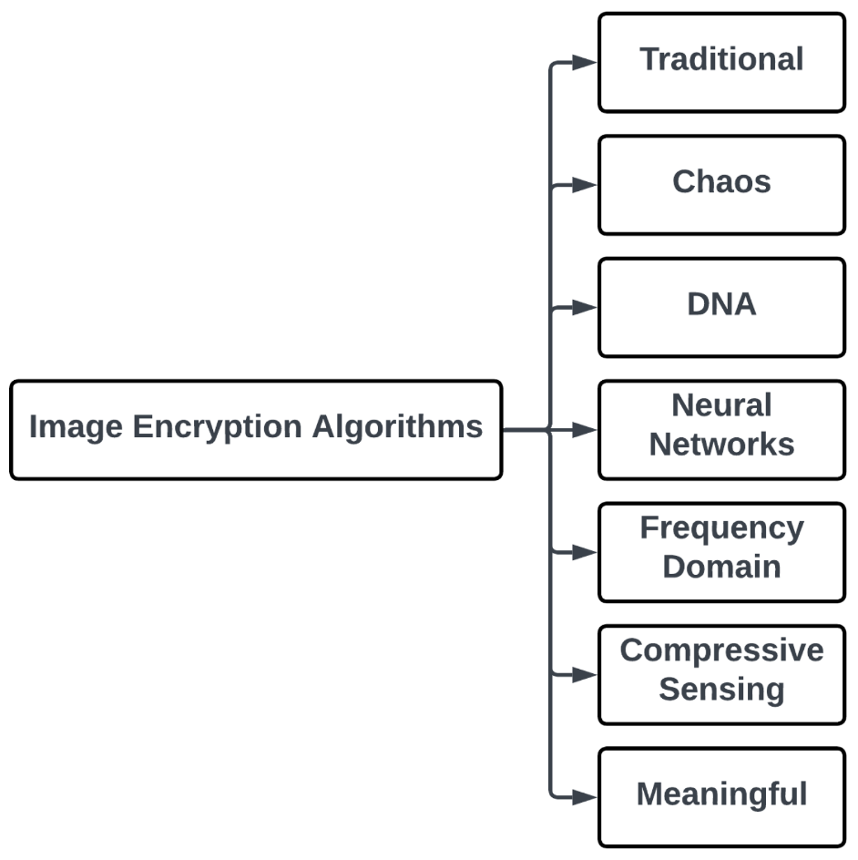

1.2 Abstract
Cryptography is art of converting one form of data into another form and in turn make the data .Unreadable for the end users. This cryptography has two methods like encryption and decryption. The process of converting plain text into cipher text is known as encryption and the process of converting cipher text into plain text is known as decryption. In this application we try to use AES algorithm for encryption or decryption of either text or image data.Now a day the use of devices such as computer, mobile and many more other devices for communication as well as for data storage and transmission has increased. As a result, there is increase in number of users. Along with these users, there is also increase in number of unauthorized users which are trying to access a data by unfair means. This arises the problem of data security. Images are sent over an insecure transmission channel from different sources, some image data contains secret data, some images itself are highly confidential hence, securing them from any attack is essentially required.
To solve this problem, we are using AES algorithm for encrypting and decrypting image. This encrypted data is unreadable to the unauthorized user. This encrypted data can be sent over network and can be decrypted using AES at the receiving end. Hence it ensures secure transmission of image.
2. Aim of the project
The project aims to develop a secure transfer of images between sender and receiver. Image should be encrypted before it is sent on a network and it should be correctly decrypted on the receiver side.
2.1 Objective of the project
• Encryption of an Image to unreadable format
• Decryption of encrypted image to original image
• Secure transfer of an image over the network such as internet
• Ensure no modifications are made while transferring over the network.
Scope of the project
Product scope
The project works by encrypting the given image using AES algorithm so that this image can be sent securely over the network. At the receiver side, the receiver has code for decrypting the image so that he can get the original image. This helps in sending confidential and sensitive information securely over the internet. Main application of this can be very helpful in medical and military fields.
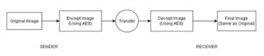
Design and Implementation constraints
• Python must be used for front end
• Encryption and Decryption should be done using AES algorithm
• Original Image must be in .jpeg/.png format.
Assumptions and Dependencies
• Sender and Receiver are connected on a network .
3.Types and Sources of File Threats
1) Unauthorized Access
“Unauthorized access” is a very high-level term that can refer to a number of different sorts of attacks. The goal of these attacks is to access some resource that your machine should not provide the attacker.
2) Executing Commands Illicitly
It’s obviously undesirable for an unknown and untrusted person to be able to execute commands on your server machines. There are two main classifications of the severity of this problem: normal user access, and administrator access. A normal user can do a number of things on a system (such as read files, mail them to other people, etc.) that an attacker should not be able to do.On the other hand, an attacker might wish to make configuration changes to a host (perhaps changing its IP address, putting a start-up script in place to cause the machine to shut down ever time it’s started or something similar). In this case, the attacker will need to gain administrator privileges on the host.
Functional Requirements
∙ The system shall encrypt the given image to an unreadable format. This is done using AES encryption function.
∙ The system shall decrypt the received encrypted image to a readable format. This is done using AES decryption function. The output image should be same as the original image.
∙ The system ensuresthat the image is securely sent over any transmission medium. Third party system cannot make modifications to the file being sent since unauthorised access is not supported.
Non-Functional Requirements
Performance Requirements
∙ For smooth & efficient encryption, image size must be less than 5MB. ∙ Decryption should not take more than 10 seconds.
Safety and Security Requirements
∙ If the decryption takes more than 10 seconds, then discard the message (because the message might have been corrupted during transmission) and ask sender to re-send it.
∙ Encryption is done using encryption key. Decryption will happen only when same encryption key is used at the receiver side.
Software Quality Attributes
Reliability
External factors do not affect the system. AES algorithm is universally accepted and generates consistent results therefore there are very less chances of errors. Error can occur only if there is a transmission glitch (the probability of which is very rare). So, the system is reliable.
Usability
It uses python based GUI which is user friendly and provides buttons for easy navigation. A person with basic understanding of computer can easily use this software for encrypting/decrypting image using key.
Testability
The system is easy to test and find defects. The system is divided into different modules performing specific functions that can be tested individually.
External Interface Requirements
User Interfaces
The interface window gives us a box for entering the location of image. Along with this box, it also contains two buttons for encoding and decoding the image. After clicking on one of these button, next window has a textbox to enter the password and a submit button. After submitting, it shows the filename of new image file generated.
Hardware Interfaces
∙ Sender Computer: for seeing the original and encrypted image
∙ Receiver Computer: for seeing the decrypted image
Software Interfaces
We have frontend made using python module named Tkinter(). This provides an interactive window for the user. The user need to provide the location of the image to be encoded/decoded. After this, user can either go for encoding or decoding the image. It asks for a password, which is basically your encryption key. After these details are entered, we use the python functions declared in the code to encode/decode the image using AES file from crypto.cypher module of python. When this process is done, the user will get encrypted/decrypted image as output which will be saved in the same directory as input image file.
Scheduling Diagrams
Gantt Chart
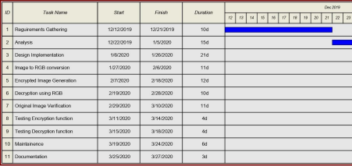Pert Chart
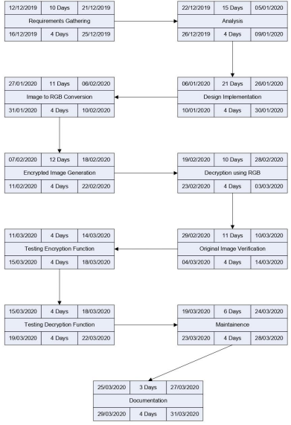
Timeline Chart
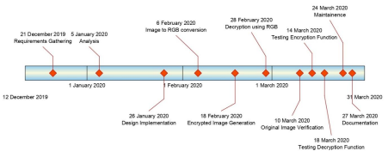
Work Breakdown Structure
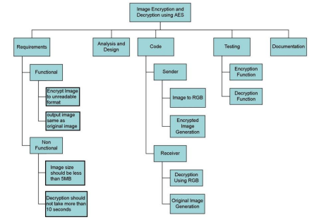
Design Diagrams
Usecase Diagram:
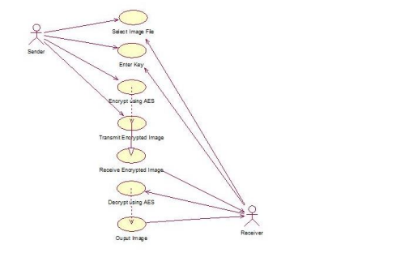Class Diagram:
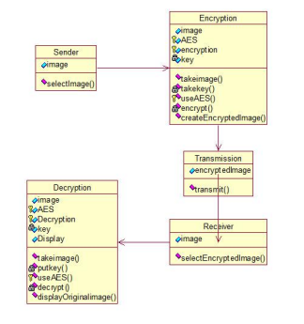
Sequence Diagram:
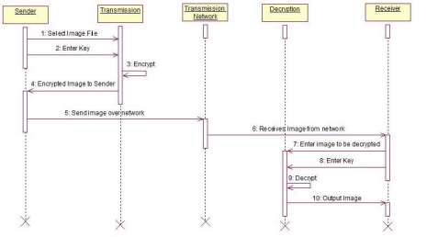
Collaboration Diagram:
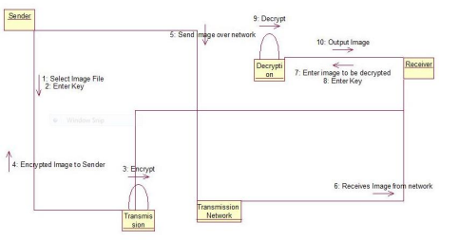
ER Diagram:
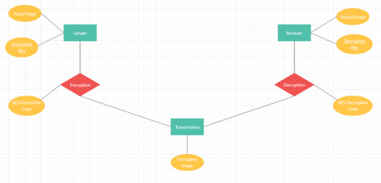
Dataflow Diagram:
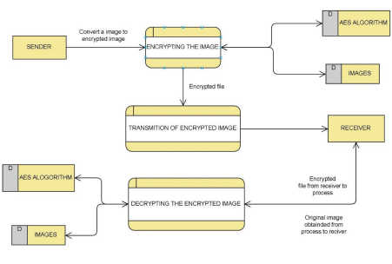
Activity Diagram:
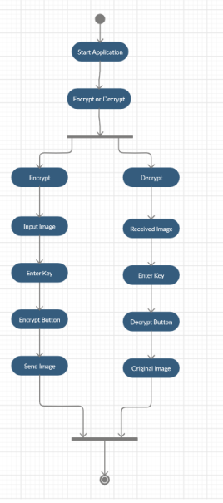
State Chart Diagram:
